Specification MA15 Mtaji
Updated: 2020-08-25/Max

General

Description
Web/Browser based system for handling B2B loans from application to repayment.
There are three stakeholders in system:
- Customer (Company that is borrowing money from Partner)
- Partner (Intermediary that is borrowing money from Mtaji and lending it out to Customer)
- Mtaji (lending money to Partner)

There are two main processes that is supported by the system:
- Customer Approval (New customer loan application)
- Loans and Payment Cycle (Handling of existing loan)

Depending on role, users should have access to different parts of the system.

Security is a main concern for this project.

Timeline and Milestones
[TBD]

Project start 24 July 2020
Project delivered in 14 days, by 3 July 2020

Milestones Frontend / App
- F1: Design implemented in app
- F2: Clickable prototype all popups, field validation etc working except API integration
- F3: Final version tested on all platforms and delivered by Developer
- F4: Final version tested and approved by End-Client

Milestones Backend
- B1: Specify Platform and 3rd party dependencies
- B2: Db structure and API calls documented
- B3: API done
- B4: Admin Panel done
- B5: Install instructions for installation on End-Client platform
- B6: Final version tested and delivered by Developer
- B7: Final version tested and approved by End-Client

All Milestones with Timeline
+0 days 19 June B1: Specify Platform and 3rd party dependencies
+3 days 22 June F1: Design implemented in app
+3 days 22 June B2: Db structure and API calls documented
+5 days 24 June B3: API done
+7 days 26 June F2: Clickable prototype all popups, field validation etc working except API integration
+9 days 28 June F3: Final version tested on all platforms and delivered by Developer
+11 days 30 June B4: Admin Panel done
+12 days 1 July B5: Install instructions for installation on End-Client platform
+14 days 3 July B6: Final version tested and delivered by Developer
+24 days 13 July F4: Final version tested and approved by End-Client
+24 days 13 July B7: Final version tested and approved by End-Client

Platforms and Versions
- Unless a specific version is specified in this document, always use latest stable version (no development / beta / alpha version)
- If there is a need to use another version, let's discuss first.

3rd Party Tools and Services
- No 3rd party tools or services except those mentioned in this document are planned for use in this project.
- If any are needed, let's discuss first. They should be widely supported (large developer community), open source and secure.

Terms and Guidelines
See Freelancer Agreement for general terms and agreed work guidelines pertaining to this project. All code, design, idea and any other information are under strict NDA.

General:
- Communicate - reply quickly, ask questions, give status updates, discuss any issues
- Time - if any delays, make sure to tell me as early as possible
- Quality - top quality and best practice, security. If any questions always ask and discuss.
- Changes - any changes or design decisions should be discussed. If you consider something additional cost, always bring it up for discussion before making changes

Reminder for all projects

Some general things that should be in all projects where applicable:
- API – no api calls without authorization. For "open" calls, eg register: create fixed authorization key
- Secure all pages, no unauthorized access to any page. For example Angular Route Guards.
- If user session expired – show alert or screen "User session expired. Click here to login again" + redirect to login page
- All settings in one single settings file if possible

File upload
- Image/file uploads, prefix filename with userid and dash, for example 34-fhfhfhf.jpg if user id is 34 (or companyid or other relevant id, if logo for company etc). Optionally store in subdirectory with id.
- Consider security – if uploaded files can be in directory that is open, or needs to ensure access only by specific users
- Image file uploads, resize images to relevant size

General for App Projects
- lost network or cannot reach api – show page "Check your internet conection" + "Try again" button
- show app version from config.xml in app (eg bottom of side menu, or about page)

More info
See app wireframes for better understanding of functions and flow.
Wireframes are available as pdf and source files.

Frontend

Technical
- Framework TBD
- Must support all modern browsers and pass W3C validation
- Responsive design, should work on small screens (cell phone) and desktop

3rd Party Tools and Services
- MailGun – SMTP email

Overview
[TODO]

Design / UI
Logo exists.
Design from 3rd party theme, needs to be selected.
- Wireframes available as pdf and Adobe XD source file
- Logo available as source files
- Design/Theme needs to be selected

Backend / API

Technical
- API: [TBD? Node.js v12 / Express v4]
- DB: MySQL / Maria DB
- Authentication: JWT

- All backend (API, Admin Panel) in same repository
- End Client platform is AWS with Plesk

Overview
Support all functions from Frontend / App Overview and Wireframes / Design.

API
- To be defined and approved before implementing
- Documentation in Swagger

DB Structure
- To be defined and approved before implementing

Below images is a very basic and incomplete structure suggestion:

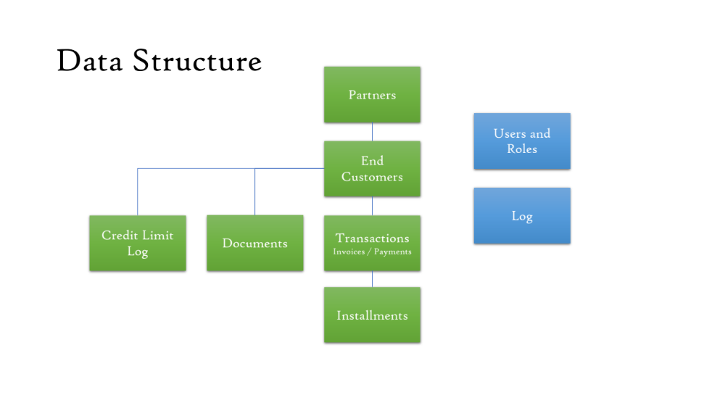
- Db should be normalized and use foreign keys to ensure data integrity
- All date/time in readable format (ISO not Unix timestamp)
- Optional fields should have default value NULL
- Id's should use int (not uuid)
- All tables should have the fields created_time, created_by (integer, user id) and updated_time, updated_by

Appendix: Comments to Wireframes

Comments to Design / Wireframes.
Any letter and number references are, eg. 1B, 5A, are to corresponding wireframes in Adobe XD.

General

- Mtaji / Partner / Customer
- All input fields can contain placeholder text with more information/help text
- All changes (updates) to fields should be logged with timestamp, userid, from value (old), to value (new)

Roles and Access
- All Access and Functionality is based on User Roles.
- One role only per user
- Five different roles: Customer, Partner, Mtaji Local Admin, Mtaji Local Credit, Mtaji Global Credit

New Customer Application

- New customer application has a total of 9 status steps. only 5 of those steps are handled by the system (1-3 and 8-9): 1) Account Creation, 2) Upload of Documents, 3) Sign off, 4) Pre-screening, 5) Credit evaluation, 6) Credit Decision, 7) Partner Decision, 8) Document sign, 9) Activate Credit
- Different user roles update different things for each status

1A Partner Register New Customer
- Access: Create: Partner, Read: Partner / Mtaji Local Admin / Mtaji Local Credit / Mtaji Global Credit, Update: None, Delete: None
- Email is sent to customer with login info
- Popup to user confirming registration

1B Customer - First Time Registration
- Access: Create: Customer, Read: Customer / Partner / Mtaji Local Admin / Mtaji Local Credit / Mtaji Global Credit, Update: None, Delete: None
- Save to db after each submit (Next/Previous) so user can exit and continue at later stage

1B2 Customer - First Time Registration - Step 2 Financial Info
- Annual Result is calculated
- If No assets is checked, fields to enter assets are hidden
- Company Assets, plus icon (+) adds another row. Plus icon is shown only on last row. (Dropdown, examples: Cars, Properties, Bank accounts, Inventory)
- Company Loans, plus icon (+) adds another row. Plus icon is shown only on last row. (Dropdown, examples: Supplier Loan, Care Loan, Machinery Loan, Property Loan, Inventory Loan, Other)

1B3 Customer - First Time Registration - Step 3 Persons
- Ownership Share is hidden if Role Owner is unchecked
- New Person headline should be Persons name, if filled
- Plus icon (+) next to headline will create a new person form on top of page, already filled out will show under
- Each person can have unlimited number of phone numbers
- Assets, plus icon (+) adds another row. Plus icon is shown only on last row. (Dropdown: Cars, Properties, Bank accounts)

1B4 Customer - First Time Registration - Step 4 Documents
- Preset (hardcoded) documents to be uploaded for Company and each person registered in Step 3

1B5 Customer - First Time Registration - Step 5 Submit
- Popup confirming application submitted
- Email to Partner with cc Mtaji that a new application has been submitted

1C New Customer Application - Sign Off
- Access: Create: Partner, Read: Partner / Mtaji Local Admin / Mtaji Local Credit / Mtaji Global Credit, Update: None, Delete: None

1D New Customer Application - Document Sign
- Access: Create: Partner, Read: Partner / Mtaji Local Admin / Mtaji Local Credit / Mtaji Global Credit, Update: None, Delete: None

1E New Customer Application - Activate Credit
- Access: Create: Mtaji Global Credit, Read: Partner / Mtaji Local Admin / Mtaji Local Credit / Mtaji Global Credit, Update: None, Delete: None

Customer Dashboard

2B Customer - Dashboard
- Only approved Customer can see Customer Dashboard
- Click contact is a simple mailto-link that will create a blank email in users mailprogram with email address to partner prefilled

Partner Dashboard

1B Partner Future Payments / Payment History
- Future payments = installments aggregated (total amount) per day
- Future: future installment dates including today
- History: installment dates before today

Appendix: Process Overviews

